**Skip The Agent**

**Design Document**

**Version 1.0**



**Group Id: F2102448D2 (BC180403635)**

**Supervisor Name: Muhammad Zubair Nawaz**

**Revision History**

|  |  |  |  |
| --- | --- | --- | --- |
| **Date (dd/mm/yyyy)** | **Version** | **Description** | **Author** |
| **05/01/2022** | **1** | The purpose of this document is to describe the implementation of “Skip the agent".   Design documentation is a collection of documents and resources that covers all aspects of your product design. Documentation should include information about users, product features, and project deadlines; all essential implementation details ERD, Test Case, Database diagram, Sequence diagram, user interface | **Bc180403635** |

**Table of Contents**

1. Introduction of Design Document page # 4
2. Entity Relationship Diagram (ERD) page # 6
3. Sequence Diagrams page # 7
4. Architecture Design Diagram page # 11
5. Class Diagram page # 12
6. Database Design page # 13
7. Interface Design page # 13
8. Test Cases page # 16

**Introduction of Design Document**

The project is to develop a Skip the agent, a web application; it provides great flexibility to buy and sell used cars by online.

**Design documentation** is a collection of documents and resources that covers all aspects of your software design**.** The document gives a brief account of different operations that are performed by system describe the relationship between these operations within as well as outside the system. This phase represents the “How” phase. Details on computer programming languages and environments, machines, packages, application architecture, distributed architecture layering, memory size, platform, algorithms, data structures, global type definitions, interfaces and many other engineering details are the deliverables of design phase. This document presents the designs used or intended to be used in implementing the project.

* **Purpose of design document:**

The purpose of the Software Design Document is to provide a description of the design of a system fully enough to allow for software development to proceed with an understanding to be built and how it is expected to build. Design documents are also referred to as functional specifications or functional specifications documents, or functional requirements specifications

* **Benefits of design document:**

1. This makes help in keep an eye on project during its development.
2. It important for marketing and investors information materials.
3. It very simple and an effective way for communication with others whose are interested in product investment.
4. It helps to keep an eye on all aspects of application and it improvements regarding software product quality.
5. Focuses on maintenance of product, development of product & about transferring of knowledge to other developers & designers.
6. It is the critical component which brings the innovation in engineering life.

The design document of this web application includes:

* Entity Relationship Diagram (ERD)
* Sequence Diagram
* Architecture Design Diagram
* Class Diagram
* Database Design
* Interface Design
* Test Cases

**Entity Relationship Diagram (ERD)**

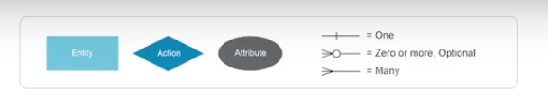

**Sequence Diagrams**









**Architecture Design Diagram**

**Class Diagram**

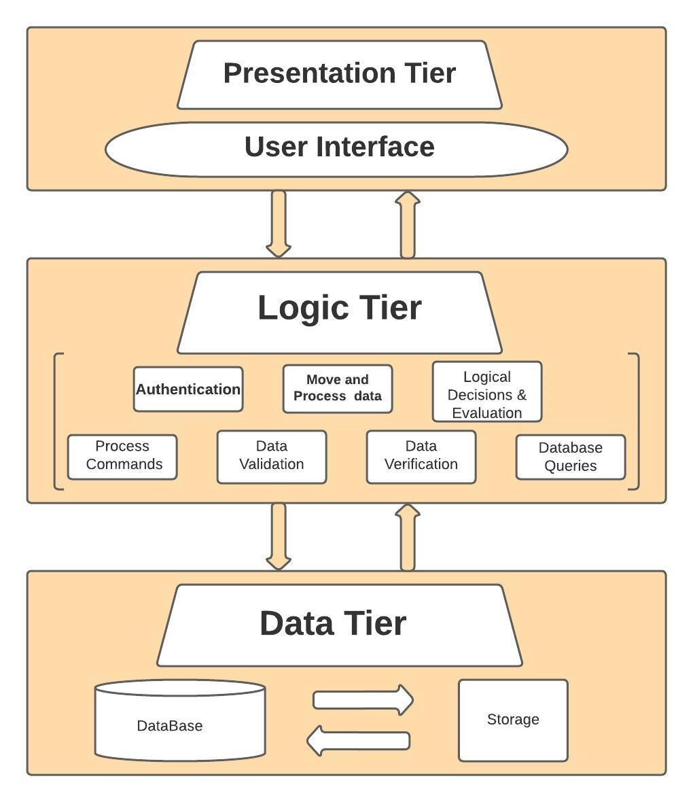



**Database Design**



**Interface Design**

* **HomePage**

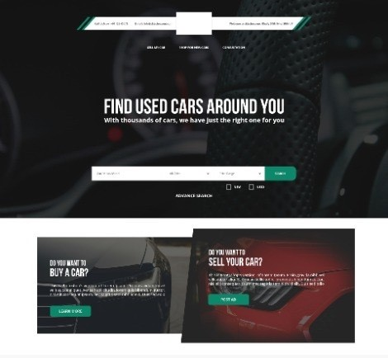

* **Sign In**

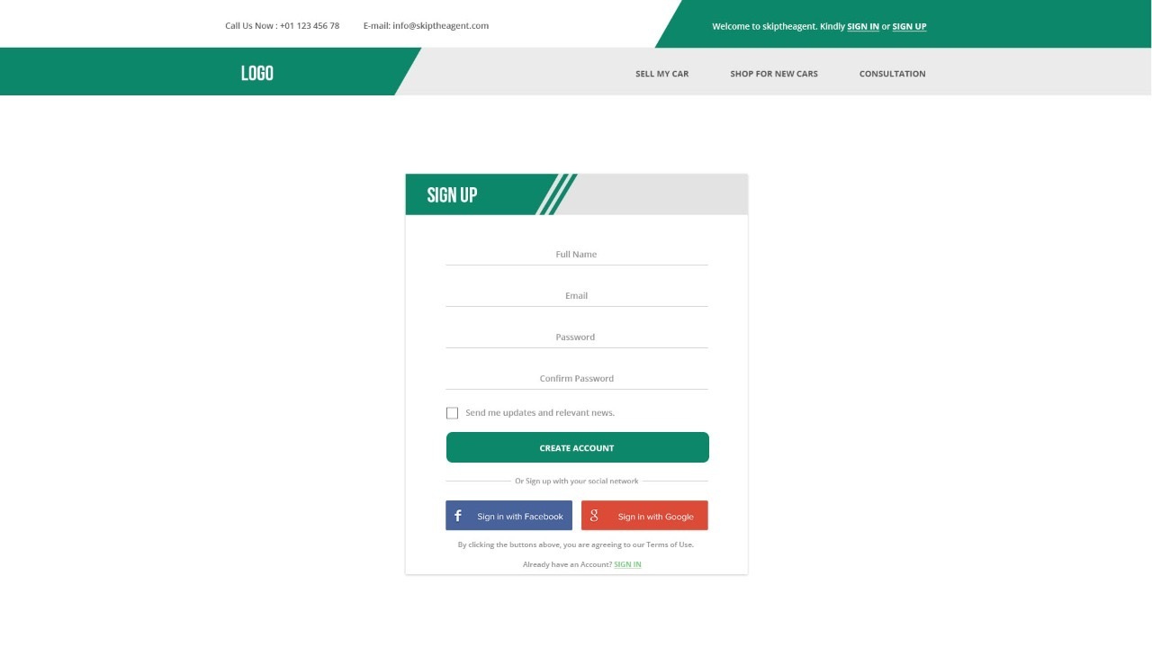

* **Product details**

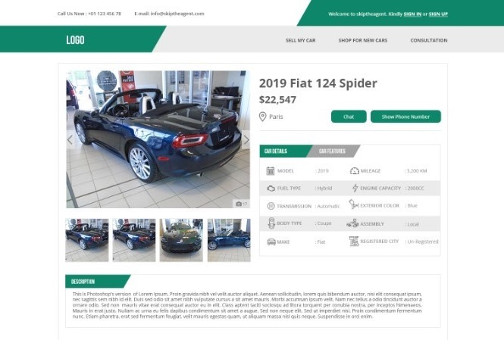

**Test** **Cases**

|  |  |
| --- | --- |
| **Test Case Title** | **Search Used Cars** |
| Test Case Id | 1 |
| Actions | Visitor will see used car details on website using different filters |
| Descriptions | This Test Case will allow the visitor to search for the cars that has been added into the website by seller. Visitor can search the car using different filters such as by their name, brand, engines, specifications and can view car details like price, name brand engine types and much more. |
| Alternative Paths | None |
| Pre-conditions | * System should be connected with the database. * Application should be running properly. * There must be at least One Faculty Member’s info |
| Post-conditions | * Visitor has searched the cars successfully |
| Author | **F2102448D2 (BC180403635)** |
| Exceptions | None |

|  |  |
| --- | --- |
| **Test Case Title** | **Registration** |
| Test Case Id | 2 |
| Actions | Register to this website database |
| Descriptions | This Test Case will allow the users to register themselves in order to post an ad for selling or to chat with other users. User will have to fill a form containing all the necessary information which is needed to complete the registration process. |
| Alternative Paths | None |
| Pre-conditions | * System should be connected with the database. * Application should be running properly. * User has a Valid Email Address. |
| Post-conditions | * The Registration was successful. |
| Author | **F2102448D2 (BC180403635)** |
| Exceptions | None |

|  |  |
| --- | --- |
| **Test Case Title** | **Login** |
| Test Case Id | 3 |
| Actions | Login to website |
| Descriptions | This Test Case will allow member to login into the site / system. They will have to enter his / her Email and Password to get login into the system |
| Alternative Paths | None |
| Pre-conditions | * System should be connected with the database * Application should be running properly. * User should have a Valid Username and Password. * User must have registered account in the application before login * User can sign in after the approval of admin |
| Post-conditions | * User logged into the system successfully. * User re-directed to his / her profile, based on his / her role in the system. |
| Author | **F2102448D2 (BC180403635)** |
| Exceptions | None |

|  |  |
| --- | --- |
| **Test Case Title** | **View Profile** |
| Test Case Id | 4 |
| Actions | Members can view their Profile |
| Descriptions | This Test Case will allow members to see their profile after they logged in to the system. User will have to click the Profile button on the top of the website in their dashboard |
| Alternative Paths | None |
| Pre-conditions | * System should be connected with the database. * Application should be running properly. * Member must have logged in with their credentials |
| Post-conditions | * Members have to click the profile element |
| Author | **F2102448D2 (BC180403635)** |
| Exceptions | None |

|  |  |
| --- | --- |
| **Test Case Title** | **Update Profile** |
| Test Case Id | 5 |
| Actions | Members will edit the profile form showing in profile section |
| Descriptions | This Test Case will allow Member to edit their profile including their password. The Member will have to save the profile after editing. They must have to enter their previous password in order to change it. |
| Alternative Paths | None |
| Pre-conditions | * System should be connected with the database. * Application should be running properly. * Member must have logged in with their credentials |
| Post-conditions | * Profile Updated Successfully Popup will show up. |
| Author | **F2102448D2 (BC180403635)** |
| Exceptions | None |

|  |  |
| --- | --- |
| **Test Case Title** | **Recover Password** |
| Test Case Id | 5 |
| Actions | User can recover the password if they forgot |
| Descriptions | This Test Case will allow the users to reset their password if they forgot it by using their registered email |
| Alternative Paths | None |
| Pre-conditions | * System should be connected with the database. * Application should be running properly. * Member must have valid email |
| Post-conditions | * Members has recovered password successfully. |
| Author | **F2102448D2 (BC180403635)** |
| Exceptions | None |

|  |  |
| --- | --- |
| **Test Case Title** | **Post Ad** |
| Test Case Id | 6 |
| Actions | Member will post an ad(s) through the form that will show up in their profile |
| Descriptions | After the login to the system, user will be able to post an ad to sell their car after filling the information that will be shown up in the website that will be viewed by visitor/student. When faculty member will log in to the system. They will redirect to their dashboard where they can add. |
| Alternative Paths | None |
| Pre-conditions | * System should be connected with the database. * Application should be running properly. * Member must have logged in with their credentials |
| Post-conditions | * Ad posted successfully |
| Author | **F2102448D2 (BC180403635)** |
| Exceptions | None |

|  |  |
| --- | --- |
| **Test Case Title** | **View / Manage their ad** |
| Test Case Id | 7 |
| Actions | User can see posted ads and can update as per they desire. |
| Descriptions | This Test Case will allow user to view their posted ad’s and which they can manage. |
| Alternative Paths | None |
| Pre-conditions | * System should be connected with the database. * Application should be running properly. * Member must have logged in with their credentials * They must have to add their details first in order to update |
| Post-conditions | * Ad updated successfully |
| Author | **F2102448D2 (BC180403635)** |
| Exceptions | None |

|  |  |
| --- | --- |
| **Test Case Title** | **Save Car ads** |
| Test Case Id | 8 |
| Actions | User can save car ads after registering by clicking save button |
| Descriptions | This Test Case will allow the user to save car ads which they can find in “Saved Ads” sections in their dashboard. |
| Alternative Paths | None |
| Pre-conditions | * System should be connected with the database. * Application should be running properly. * There must be at least One Faculty Member’s info |
| Post-conditions | * Ad Saved Successfully |
| Author | **F2102448D2 (BC180403635)** |
| Exceptions | None |

|  |  |
| --- | --- |
| **Test Case Title** | **Create Alert** |
| Test Case Id | 9 |
| Actions | User can create alert for their desire cars |
| Descriptions | This Test Case will allow the user to create alert for their specific cars, they will get notified as soon the car is available for selling. |
| Alternative Paths | None |
| Pre-conditions | * System should be connected with the database. * Application should be running properly. * There must be at least One Faculty Member’s info |
| Post-conditions | * Alert created successfully |
| Author | **F2102448D2 (BC180403635)** |
| Exceptions | None |

|  |  |
| --- | --- |
| **Test Case Title** | **Manage Users / Ads (Admin)** |
| Test Case Id | 10 |
| Actions | Admin can view, ads and users that are registered with system |
| Descriptions | This Test Case will allow admin to view the information as well as admin can manage them accordingly. |
| Alternative Paths | None |
| Pre-conditions | * System should be connected with the database. * Application should be running properly. * Admin must have logged in with their credentials * There must be at least one faculty member’s info |
| Post-conditions | * Details will be update accordingly |
| Author | **F2102448D2 (BC180403635)** |
| Exceptions | None |